INTERNSHIP PROJECT SUBMISSION
Predicting One-Year Diabetes
Disease Progression
from Baseline Patient Measurements
Final Data Science Capstone Report
Python · pandas · scikit-learn · SciPy · Matplotlib · seaborn · Regression · Error Analysis
Model comparison, error analysis and high-risk patient insights
Educational project – not a medical device
Name: | Lokesh Patwal
Internship/Program: | Data Science Intern
Organization: | Yuva Intern
Internship Period: | 01 October 2026 – 26 November 2026
Date: | 07 November 2026

Table of Contents
Chapter 1: Introduction
1.1 Background
1.2 About this project
1.3 Structure of the report
Chapter 2: Problem Statement and Objectives
2.1 Problem statement
2.2 Motivation and stakeholders
2.3 Objectives
2.4 Analytical questions
2.5 Scope, requirements and success criteria
Chapter 3: Background Study
3.1 The diabetes dataset in the literature
3.2 Linear and regularised regression
3.3 Tree-based models
3.4 Evaluation and model selection
3.5 Interpretation and statistical tests
3.6 Software
Chapter 4: Dataset Description and Data Collection
4.1 Source and conditions of use
4.2 Reproducible access
4.3 Size and variables
4.4 Why this dataset was suitable
4.5 Limitations and possible biases
Chapter 5: Methodology and Project Workflow
5.1 Workflow
5.2 Tools
5.3 Evaluation design
5.4 Model selection rule
Chapter 6: Data Cleaning and Preprocessing
6.1 Data-quality checks
6.2 Treatment of outliers
6.3 Preprocessing steps
Chapter 7: Exploratory Data Analysis
7.1 The target variable
7.2 Distribution of the predictors
7.3 Relationship of each predictor with progression
7.4 Relationships among the predictors
7.5 Feature engineering
Chapter 8: Data Science Techniques and Model Development
8.1 Algorithms and the reasons for choosing them
8.2 Hyperparameter tuning
8.3 Comparison of the models
8.4 Selection of the final model
Chapter 9: Model Evaluation and Error Analysis
9.1 Metrics
9.2 Performance of all models
9.3 Performance of the final model
9.4 Overfitting and underfitting
9.5 Error analysis
Chapter 10: Results and Findings
10.1 Which measurements drive the prediction?
10.2 High-risk patient segments
10.3 Success criteria
10.4 Extension: flagging patients likely to progress quickly
10.5 Summary of findings
Chapter 11: Insights and Recommendations
11.1 Insights
11.2 Recommendations
11.3 Expected benefits, risks and assumptions
Chapter 12: Limitations and Future Scope
12.1 Limitations
12.2 Future scope
Conclusion
References
Appendix
Appendix A: Objective-to-evidence map
Appendix B: Key code
Appendix C: How to reproduce the results
List of Figures
Figure 7.1: Distribution of disease progression in the training set
Figure 7.2: Distribution of each predictor
Figure 7.3: Correlation of each predictor with progression
Figure 7.4: Progression plotted against the four most informative predictors
Figure 7.5: Correlation heat map of all variables
Figure 7.6: Variance inflation factors
Figure 7.7: Progression by the engineered groups
Figure 8.1: Comparison of the models by cross-validation
Figure 9.1: Actual and predicted progression for the test patients
Figure 9.2: Training, cross-validated and test errors of all models
Figure 9.3: Learning curve of the final model
Figure 9.4: Residual diagnostics
Figure 9.5: Prediction error by level of actual progression
Figure 10.1: Permutation importance and Ridge coefficients
Figure 10.2: Partial dependence of predicted progression on BMI and s5
Figure 10.3: Progression by number of risk indicators
Figure 10.4: ROC curve and alert thresholds for fast progressors

List of Tables
Table 2.1: The analytical questions of the project
Table 4.1: Variables of the diabetes dataset
Table 5.1: Tools and their purposes
Table 6.1: Results of the data-quality checks
Table 7.1: Engineered features
Table 8.1: Algorithms compared
Table 8.2: Hyperparameter search and best settings
Table 9.1: Performance of all models (RMSE and MAE in progression points)
Table 9.2: Final model on the 89 unseen test patients
Table 10.1: Classical regression (OLS) coefficients on the training patients
Table 10.2: Progression by number of risk indicators
Table 10.3: Success criteria set in Chapter 2 and the outcome
Table 10.4: Alerts raised at three cut-offs of the predicted score
Table 10.5: Main findings
Table 11.1: Recommendations
Table A.1: Official objectives and where they are demonstrated

Chapter 1: Introduction

1.1 Background
Diabetes is a long-term condition in which the body cannot keep the level of sugar in the blood under control. For some patients the condition worsens slowly, while for others it worsens quickly, and it is difficult to know in advance which patients belong to which group. Clinics that run diabetes programmes have a limited number of appointments and a limited number of staff. A tool that can use the measurements already taken at the first visit to point out the patients who are most likely to worsen would therefore help them to plan follow-up visits, to focus advice on the groups that need it most, and to decide which additional data they should start collecting.
Data science offers a set of methods for building such a tool: careful data checking, exploratory analysis, statistical testing, machine-learning models and honest evaluation. This capstone project applies the complete workflow, from the definition of the problem to the presentation of results, to a real and widely used research dataset.

1.2 About this project
The project is the final capstone of the Data Science internship with Yuva Intern, whose official task is to showcase all learned skills in a comprehensive final project. Three realistic project ideas were compared before the work started. Customer churn prediction and employee attrition analysis are attractive business problems, but the usual public datasets for them could not be downloaded in the environment in which the project was built, and the use of invented data would have made every result meaningless. The third idea, predicting disease progression in diabetes patients, was chosen because the data are real, published, available without any account, and suitable for every stage of the workflow: cleaning, exploratory analysis, feature engineering, several models, error analysis and recommendations.

1.3 Structure of the report
Chapter 2 states the problem and the objectives. Chapter 3 gives the background to the methods. Chapter 4 describes the dataset, and Chapter 5 the methodology. Chapters 6 and 7 cover data cleaning, preprocessing and exploratory analysis. Chapters 8 and 9 describe model development, evaluation and error analysis. Chapter 10 presents the results, Chapter 11 the insights and recommendations, and Chapter 12 the limitations and future scope. The report ends with a conclusion, references and an appendix.
Educational notice. This is a learning project on a historical research dataset. It is not a medical device and gives no medical advice. All recommendations are analytical proposals that would need clinical review and validation.

Chapter 2: Problem Statement and Objectives

2.1 Problem statement
Using only the measurements taken at the start (age, sex, body mass index, blood pressure and six blood-serum values), the project asks whether it is possible to predict how much a patient's disease will have progressed one year later, how reliable this prediction is, and which patient groups are at the highest risk of fast progression.

2.2 Motivation and stakeholders
A reasonably accurate prediction would help a clinic to schedule follow-up, to focus lifestyle advice on higher-risk groups and to decide what extra data to collect. Even a modest model is useful if its limits are understood and clearly stated. The stakeholders in this project are assumed for the purpose of the exercise: a clinic or diabetes-programme manager, doctors and nurses who plan follow-up, and a data team that maintains the model. No real clinic took part in the project.

2.3 Objectives
The seven objectives of the capstone follow the official internship task:
- Define the capstone problem, its scope, requirements and expected outcomes.
- Collect and prepare the data: cleaning, preprocessing, feature engineering and exploratory analysis.
- Apply appropriate statistical methods and machine-learning algorithms.
- Build the solution and evaluate its performance with suitable metrics.
- Analyse results, errors, limitations and opportunities for improvement.
- Generate insights and practical, data-driven recommendations, supported by visualisations.
- Document and present the whole capstone in a report and a presentation.

2.4 Analytical questions
Table 2.1 lists the seven questions that guided the analysis.
Table 2.1: The analytical questions of the project
No. | Question | Answered in
Q1 | Is the data complete and consistent enough to model? | Chapter 6
Q2 | How is disease progression distributed, and which measurements are related to it? | Chapter 7
Q3 | Are the predictors related to each other in ways that affect modelling? | Chapter 7
Q4 | Do engineered features improve prediction? | Chapter 7
Q5 | Which model predicts best, and does it generalise to unseen patients? | Chapters 8 and 9
Q6 | Where and why does the model make large errors? | Chapter 9
Q7 | Which measurements and patient groups carry the highest risk of fast progression? | Chapters 10 and 11

2.5 Scope, requirements and success criteria
In scope: one public dataset of 442 patients; regression models; evaluation; interpretation; and segmentation of patients by risk. Out of scope: clinical validation, treatment decisions, causal claims and deployment in a hospital. Requirements: Python with free open-source libraries, results that can be reproduced by anyone with the project files, and a clear statement of every limitation.
The following success criteria were fixed before the results were examined: (a) the data quality is fully documented; (b) the final model reduces the test and cross-validated RMSE by more than 25 % compared with always predicting the average; (c) there is no sign of overfitting, meaning that the cross-validated error is close to the training error; (d) errors are analysed by patient group; and (e) at least three recommendations are given, each linked to a finding. Chapter 10 reports whether each criterion was met.

Chapter 3: Background Study

3.1 The diabetes dataset in the literature
The diabetes dataset used in this project was introduced by Efron, Hastie, Johnstone and Tibshirani (2004) in their paper on Least Angle Regression. In that paper it served to illustrate how a small number of useful predictors can be selected from a larger set. Since then it has become a standard teaching example for regression, which makes it suitable for an internship project: its behaviour is well known, and results can be compared with other published work.

3.2 Linear and regularised regression
Linear regression describes the target as a weighted sum of the predictors and is the usual starting point because it is simple and easy to explain (Hastie, Tibshirani and Friedman, 2009). When several predictors carry similar information, which is called multicollinearity, the individual weights become unstable. Ridge regression (Hoerl and Kennard, 1970) adds a penalty on the size of the weights and so stabilises them, while the lasso (Tibshirani, 1996) uses a different penalty that can set the weights of weak predictors to zero.

3.3 Tree-based models
A decision tree splits the patients into groups by a sequence of simple rules (Breiman et al., 1984). Single trees are easy to read but unstable. Random forests (Breiman, 2001) average many trees built on random samples of the data, and gradient boosting (Friedman, 2001) builds trees one after another, each correcting the errors of the previous ones. Both can capture non-linear effects and interactions, but they need enough data to do so.

3.4 Evaluation and model selection
Regression models are judged by the size of their errors. The mean absolute error (MAE) is the average error in the original units; the root mean squared error (RMSE) punishes large mistakes more strongly; and R-squared is the share of the variation that the model explains. To obtain a trustworthy estimate, the data are split into training and test parts, and the settings of each model are chosen by cross-validation on the training part only. When several models perform almost equally well, the one-standard-error rule recommends the simplest of them (Hastie, Tibshirani and Friedman, 2009). The bootstrap (Efron and Tibshirani, 1993) is used to attach an uncertainty interval to the test results.

3.5 Interpretation and statistical tests
Permutation importance, which measures how much the error rises when one column is randomly shuffled, was introduced in connection with random forests (Breiman, 2001). Differences between groups were tested with the Kruskal-Wallis test (Kruskal and Wallis, 1952) and the Mann-Whitney test (Mann and Whitney, 1947), which do not assume a normal distribution, and normality of the residuals was checked with the Shapiro-Wilk test (Shapiro and Wilk, 1965). Effect sizes were expressed with Cohen's d (Cohen, 1988). When the question is changed to "is this patient a fast progressor?", the area under the ROC curve (Hanley and McNeil, 1982) measures how well the model ranks fast progressors above the others.

3.6 Software
The analysis uses Python with NumPy (Harris et al., 2020), pandas (McKinney, 2010), SciPy (Virtanen et al., 2020), scikit-learn (Pedregosa et al., 2011), Matplotlib (Hunter, 2007) and seaborn (Waskom, 2021).

Chapter 4: Dataset Description and Data Collection

4.1 Source and conditions of use
The data are the diabetes dataset of Efron, Hastie, Johnstone and Tibshirani (2004), as distributed with scikit-learn (sklearn.datasets.load_diabetes). The source page named in the scikit-learn documentation is https://www4.stat.ncsu.edu/~boos/var.select/diabetes.html. That page could not be opened from the environment in which the project was built, so the data were read from the copy bundled with scikit-learn. The dataset is a widely used public research dataset, and scikit-learn does not state a separate data licence; it is used here for education, with full citation.

4.2 Reproducible access
scikit-learn normally returns a mean-centred and scaled version of the data. This project loads the original units with the instruction load_diabetes(as_frame=True, scaled=False).frame. No download and no account are needed, and the notebook also saves a plain CSV copy to data/raw/diabetes_raw.csv.

4.3 Size and variables
The dataset has 442 patients and 11 columns: ten predictors and one target. All columns are numeric. The target, progression, is a quantitative measure of disease progression one year after baseline; it ranges from 25 to 346 with a mean of 152.1, and the source gives no unit or formula for it. The meaning of the columns is given in Table 4.1.
Table 4.1: Variables of the diabetes dataset
Column | Meaning | Type
age | Age in years | numeric
sex | Sex, coded 1 and 2 (the source does not say which code is which) | binary code
bmi | Body mass index | numeric
bp | Average blood pressure | numeric
s1 | tc: total serum cholesterol | numeric
s2 | ldl: low-density lipoproteins | numeric
s3 | hdl: high-density lipoproteins | numeric
s4 | tch: total cholesterol divided by HDL | numeric
s5 | ltg: possibly the logarithm of the serum triglycerides level | numeric
s6 | glu: blood sugar level | numeric
progression | Target: disease progression one year after baseline | numeric

All ten predictors are numeric, and sex is a two-valued code that is treated as a binary variable. Categorical groups, such as the BMI class and the age group, are created later by feature engineering. Ages run from 19 to 79 years and BMI from 18.0 to 42.2. The two sex codes are almost evenly split (235 patients with code 1 and 207 with code 2).

4.4 Why this dataset was suitable
The data are real, they are available offline and without credentials, and the target is a clear numeric quantity. The number of patients is large enough for cross-validation, the variables can be interpreted, and the dataset is a known benchmark for regression.

4.5 Limitations and possible biases
Only 442 patients are available, and they come from one source. Nothing is known about how the patients were selected or where and when they were treated. The target has no stated unit, the meaning of the sex codes is not documented, and only baseline values at a single point in time are given. A model built on these data therefore cannot be assumed to work in other populations.

Chapter 5: Methodology and Project Workflow

5.1 Workflow
The project follows the usual data-science workflow in nine steps: (1) define the problem; (2) load and understand the data; (3) clean the data; (4) split the data into training and test sets; (5) explore the training data; (6) engineer and test new features; (7) train and tune the models by cross-validation; (8) evaluate the selected model once on the test set and analyse its errors; and (9) interpret the results and write recommendations. The order of the steps was designed to prevent data leakage, which means that information from the test patients must never influence the training of the models.

5.2 Tools
Table 5.1 lists the tools. Everything is free and open source, and every random step uses random_state = 42, so the results can be reproduced exactly.
Table 5.1: Tools and their purposes
Tool | Purpose in this project
Python 3 | Programming language
Jupyter Notebook | Executable analysis document (notebooks/Final_Data_Science_Capstone.ipynb)
NumPy, pandas | Numerical computing and data handling
SciPy | Statistical tests (Mann-Whitney, Kruskal-Wallis, Shapiro-Wilk, Spearman correlation)
scikit-learn | Models, pipelines, cross-validation, metrics, permutation importance
Matplotlib, seaborn | Charts
src/project_code.py | Reusable and tested functions (32 automated tests)

5.3 Evaluation design
Eighty per cent of the patients (353 patients) form the training set, and twenty per cent (89 patients) form the test set, which is locked away until the final evaluation. The split is stratified: the patients are grouped into five progression bands so that both sets contain a similar spread of the target. Model settings are tuned by grid search with five-fold cross-validation repeated twice on the training set, scored by RMSE. The test set is used once, to measure the performance of the final model.

5.4 Model selection rule
The rule was fixed in advance and uses cross-validation results only. Among the tuned models whose cross-validated RMSE is within one standard error of the best, the simplest and most interpretable model is chosen. A slightly more accurate but harder-to-explain model is not worth the extra complexity when the difference is within the noise of the estimate.

Chapter 6: Data Cleaning and Preprocessing

6.1 Data-quality checks
Cleaning means checking that the table is complete, unique and sensible before any model uses it. The checks cover missing values, duplicate rows, data types, impossible values, internal consistency between related columns and outliers. Table 6.1 summarises the results.
Table 6.1: Results of the data-quality checks
Check | Result | Decision
Missing values | 0 missing cells | No imputation is needed. The modelling pipeline still contains an imputer so that it would not fail on incomplete new data.
Duplicate rows | 0 | No patient is counted twice.
Data types | All columns are numeric | sex is a code, not a quantity, so it is recoded to a 0/1 variable sex_2.
Impossible values | None (no negative, zero, infinite or out-of-range entries) | None needed.
Consistency of s4 with s1 / s3 | Correlation 0.979; mean absolute difference 0.21; largest difference 0.65 | The source does not explain the small differences (rounding is a likely reason), so s4 is kept as supplied.
Outliers (1.5 x IQR rule) | 40 values in 31 patients: bmi (3), s1 (8), s2 (7), s3 (7), s4 (2), s5 (4), s6 (9) | Kept (see below).

6.2 Treatment of outliers
The outliers are not impossible values, they are a small share of the data, and removing them would delete exactly those patients with unusual blood values whom a risk model should understand. As a safeguard, the model was also trained without the 24 training patients that contain a flagged value. The test RMSE was then 52.1 (R-squared 0.55), compared with 52.0 (0.55) when they are included, so the conclusions do not depend on the outliers.
Cleaning outcome. No rows were removed and no values were changed. The data are complete and unique.

6.3 Preprocessing steps
The order of the steps matters for the prevention of data leakage. First, simple columns were recoded or engineered (sex_2, BMI class, age group and the LDL/HDL ratio). These use only each patient's own values and cannot leak information. Second, the data were split into training and test sets before any exploration. Third, imputation, scaling and encoding were placed inside a pipeline so that they are learned from the training rows of each cross-validation fold only, never from the validation or test rows. Finally, the decision on which features to use was made by cross-validation on the training set (Section 7.5).
The split produced 353 training and 89 test patients. The target has almost the same average and spread in both sets (training mean 151.9, standard deviation 77.0; test mean 152.9, standard deviation 78.1), so the test set is a fair sample. All exploratory analysis in Chapter 7 uses the training patients only.

Chapter 7: Exploratory Data Analysis
Exploratory data analysis answers questions Q2 to Q4. Each chart below is followed by what it shows, what was observed and what it means.

7.1 The target variable
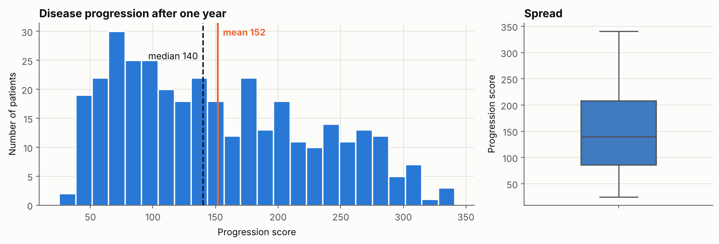
Figure 7.1: Distribution of disease progression in the training set
The histogram counts patients by progression score, and the box plot summarises the spread. The scores are spread widely and fairly evenly between about 25 and 346. The skewness is only 0.43 and the excess kurtosis is -0.88, which means that the distribution is flatter than a bell curve. The quartiles are 86, 140 and 208, and there are no extreme outliers. A numeric (regression) approach is therefore suitable and the target needs no transformation. Because the patients differ so much, even an approximate prediction can help to rank them.

7.2 Distribution of the predictors
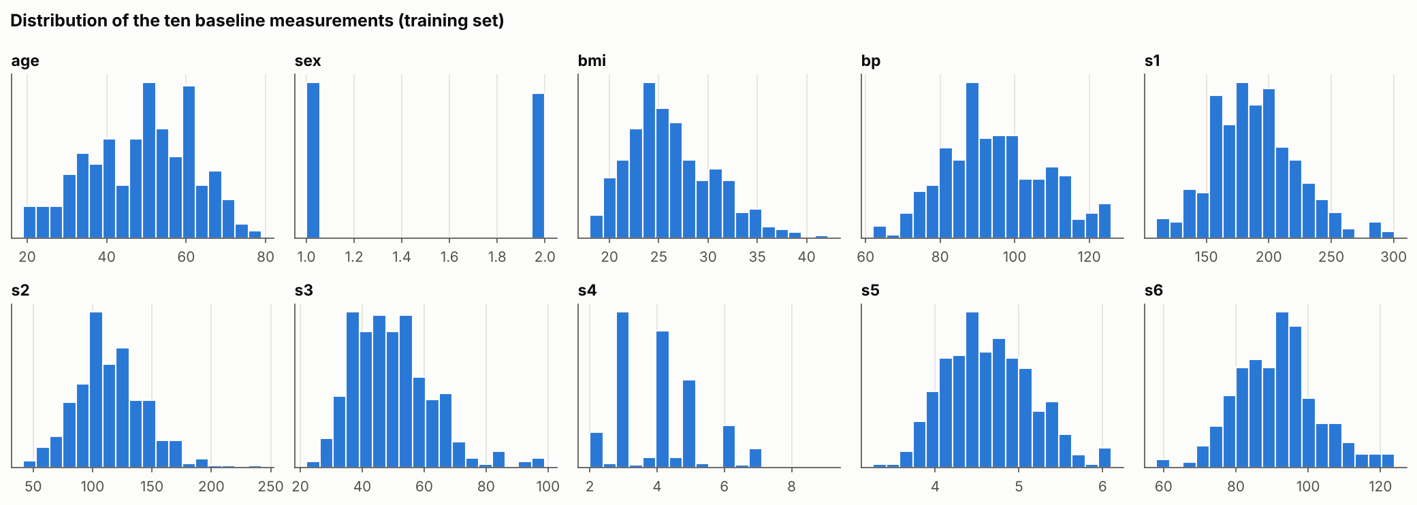
Figure 7.2: Distribution of each predictor
All skewness values are below 1 in size. The most skewed are s3 (0.87), s4 (0.70) and bmi (0.63), each with a modest tail to the right. The distributions are reasonable for both linear and tree models, so no logarithmic or power transformations were applied.

7.3 Relationship of each predictor with progression
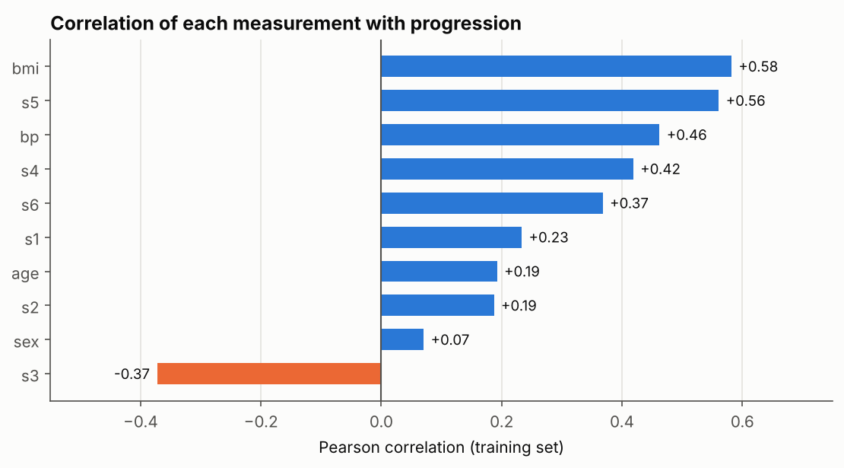
Figure 7.3: Correlation of each predictor with progression
Each bar is the Pearson correlation between one measurement and progression. The strongest relationships are bmi (+0.58), s5 (+0.56) and bp (+0.46), followed by s4 (+0.42), s3 (-0.37, which is negative: higher HDL goes with slower progression) and s6 (+0.37). The measurements s1, age and s2 are weak but present (+0.23, +0.19 and +0.19). With ten tests, the Bonferroni threshold is p below 0.005; using Spearman rank correlation, nine of the ten predictors pass it. The variable sex does not: mean progression is 146.7 for code 1 and 157.5 for code 2 (Mann-Whitney p = 0.26, Cohen's d = 0.14), a small and non-significant difference.
These are associations. A correlation does not show that BMI or triglycerides cause faster progression, because other unmeasured factors such as diet, medication and the duration of illness may influence both.
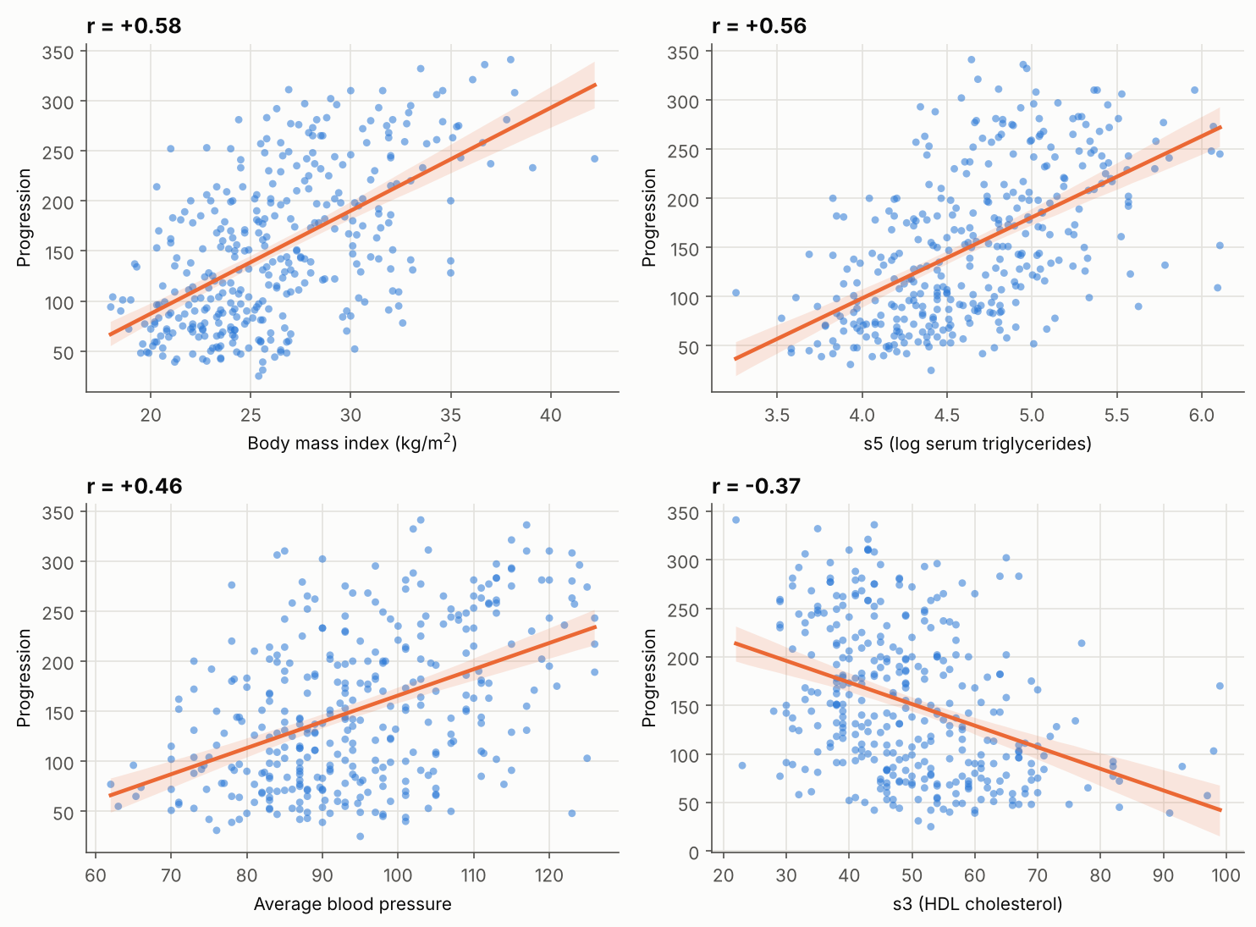
Figure 7.4: Progression plotted against the four most informative predictors
The relationships are positive for BMI, s5 and blood pressure and negative for HDL (s3). The cloud of points around each line is wide: BMI alone accounts for about 34 % of the variation and s5 for about 31 %. There is no strong curvature, which suggests that a linear model may do well, while the large individual scatter warns that predictions will be approximate.

7.4 Relationships among the predictors
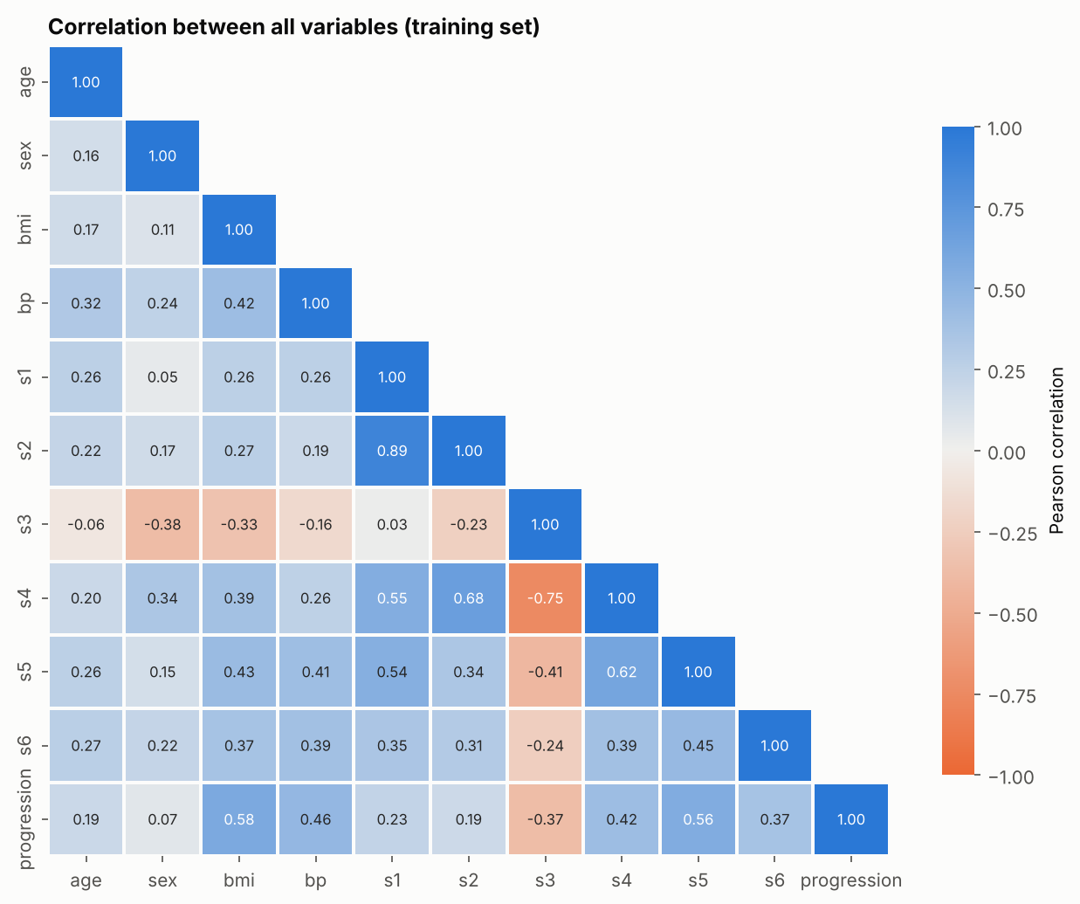
Figure 7.5: Correlation heat map of all variables
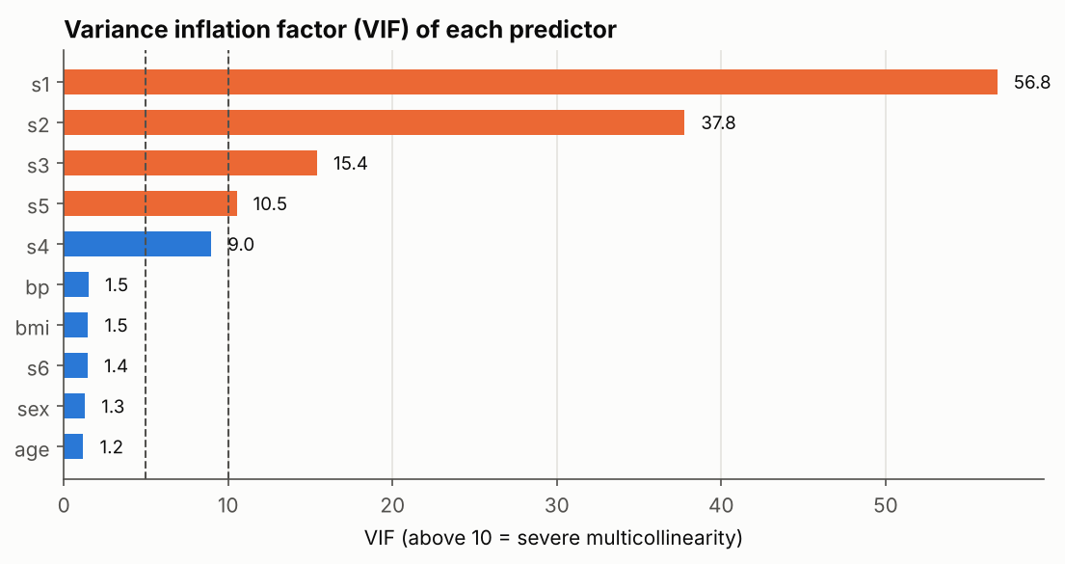
Figure 7.6: Variance inflation factors
The heat map shows how strongly every pair of variables moves together, and the bar chart shows the variance inflation factor (VIF), which tells how much of each predictor can be reproduced from the others; a value above 10 is usually considered severe. Two pairs of predictors are strongly related: s1 and s2 (r = +0.89; total and LDL cholesterol) and s3 and s4 (r = -0.75; HDL and the cholesterol/HDL ratio). The VIF is very high for s1 (56.8), s2 (37.8), s3 (15.4) and s5 (10.5), and borderline for s4 (9.0); the other predictors are below 2.
The lipid measurements overlap. Predictions are hardly affected by this, but the individual coefficients of s1 to s4 become unstable and cannot be interpreted one by one. This is why the regularised models (Ridge and Lasso) were tried, and why importance is interpreted for groups of variables.

7.5 Feature engineering
Feature engineering adds columns that express domain knowledge. Each new feature was added for a stated reason and was tested rather than assumed to help (Table 7.1).
Table 7.1: Engineered features
New feature | Definition | Reason
sex_2 | 1 if the sex code is 2, otherwise 0 | Turns a code into a proper binary variable.
bmi_category | BMI under 25, 25 to 29.9, and 30 and over | Standard adult BMI cut-offs of the World Health Organization (2000), which clinicians use. The underweight class (under 18.5) has only 2 patients and is merged with the first class.
age_group | 19 to 39, 40 to 49, 50 to 59 and 60 and over | Allows a stepwise age effect.
ldl_hdl_ratio | s2 / s3 | A common lipid-balance measure that combines two related predictors.

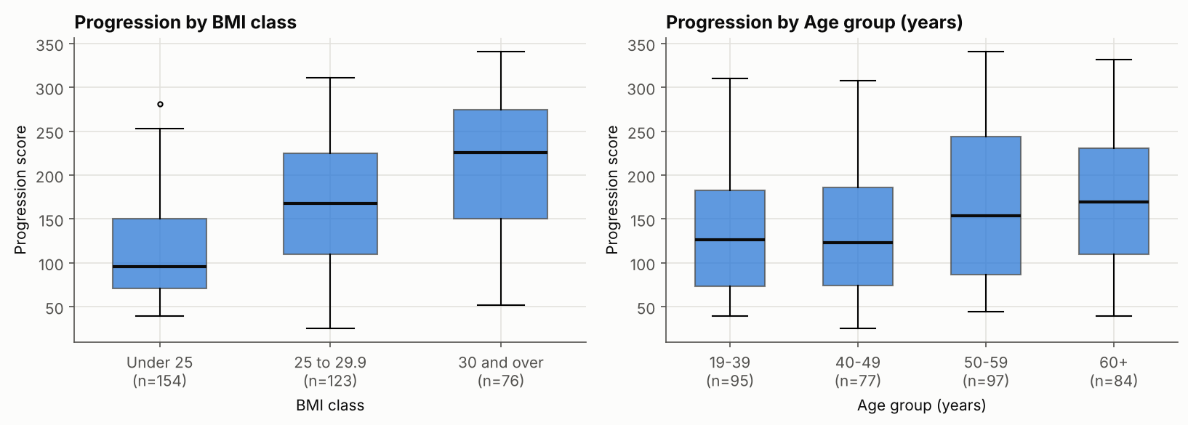
Figure 7.7: Progression by the engineered groups
Progression rises steeply across the BMI classes: 110.9 for BMI under 25 (n = 154), 165.1 for 25 to 29.9 (n = 123) and 213.8 for 30 and over (n = 76); the Kruskal-Wallis p-value is 9.6e-21. Age shows a milder step: 133.6, 138.9, 163.9 and 170.7 for the four groups (p = 0.0017). The LDL/HDL ratio correlates +0.33 with progression, which is no stronger than HDL alone (-0.37).
Do the engineered features improve prediction? Under the rule fixed in advance (adopt them only if the cross-validated RMSE falls by more than one standard error for both test models), they did not. The RMSE changed by +0.35 for Ridge and +0.34 for Gradient Boosting, where a positive change means slightly worse, against a standard error of about 1.9. The models already contain the underlying numbers, so the groups add no new information. The final models therefore use the ten original predictors, with sex as sex_2. The groups remain useful for explaining results to non-technical readers (Chapter 10).

Chapter 8: Data Science Techniques and Model Development

8.1 Algorithms and the reasons for choosing them
Seven approaches were compared (Table 8.1). Every model is a pipeline of an imputer, a scaler and the model itself, so that all preprocessing is learned from training data only.
Table 8.1: Algorithms compared
Algorithm | Why it was chosen
Baseline (predict the training average) | The minimum standard that any model must beat.
Linear Regression | Simple, transparent and a strong benchmark when relationships are roughly straight, as seen in Section 7.3.
Ridge | Linear model with a penalty that stabilises coefficients when predictors overlap (Section 7.4).
Lasso | Linear model whose penalty can switch weak predictors off.
Decision Tree | Easy-to-read if-then rules that can capture non-linear steps, but unstable.
Random Forest | Average of many trees; can capture non-linear effects and interactions.
Gradient Boosting | Trees built one after another, each correcting the previous ones. XGBoost was not available in the build environment; scikit-learn's Gradient Boosting belongs to the same family.

8.2 Hyperparameter tuning
The settings of each model were tuned by grid search with five-fold cross-validation repeated twice on the training set only, scored by RMSE. The size of each search and the best settings found are given in Table 8.2.
Table 8.2: Hyperparameter search and best settings
Model | Settings tried | Best settings | Best cross-validated RMSE
Ridge | 26 | alpha=25.12 | 55.01
Lasso | 25 | alpha=1 | 55.04
Linear Regression | 1 | none | 55.18
Decision Tree | 16 | max_depth=4, min_samples_leaf=30 | 61.67
Random Forest | 27 | max_depth=5, max_features=0.6, min_samples_leaf=6 | 56.14
Gradient Boosting | 36 | learning_rate=0.01, max_depth=2, n_estimators=400, subsample=0.7 | 56.24

8.3 Comparison of the models
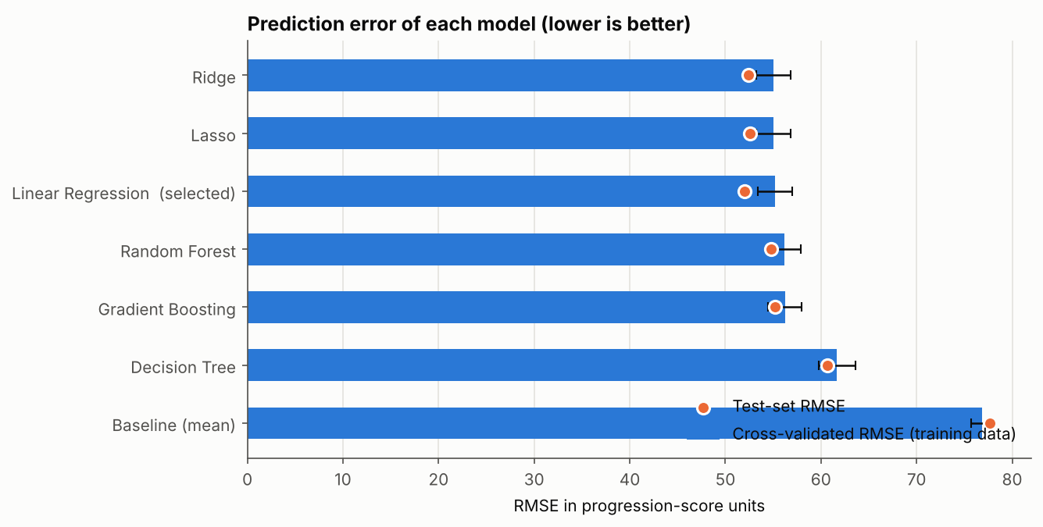
Figure 8.1: Comparison of the models by cross-validation
The linear models reached a cross-validated RMSE of about 55.0, the two tree ensembles about 56.1 and 56.2, and the single decision tree 61.7. The baseline scored 76.9. Five of the six models are within about one standard error (about 1.8) of each other, so the flexible models gave no real advantage over the linear ones. This fits the nearly straight relationships seen during the exploratory analysis. The single tree is clearly worse because one tree is unstable and, with only 353 training patients, each leaf contains few patients.

8.4 Selection of the final model
The lowest cross-validated RMSE belongs to Ridge (55.01). The one-standard-error limit is 56.82, and five models fall inside it: Linear Regression, Ridge, Lasso, Gradient Boosting, Random Forest. The simplest of these is Linear Regression, which has no hyperparameters, and it is therefore the selected final model. The selection used cross-validation only; the test set played no part in it.

Chapter 9: Model Evaluation and Error Analysis

9.1 Metrics
For regression, three families of metrics are used. The MAE is the average size of the error in progression points; it is easy to explain and treats all errors equally. The MSE and RMSE square the errors and therefore punish large mistakes more strongly; RMSE returns to the original scale and is the main metric here because large misses on high-risk patients matter most. R-squared is the share of the variation in progression that the model explains: zero means no better than the average and one means perfect. Accuracy, precision, recall, F1-score and ROC-AUC apply to classification and are used in the extension in Section 10.4, where the question becomes "is this patient a fast progressor?".

9.2 Performance of all models
Table 9.1: Performance of all models (RMSE and MAE in progression points)
Model | CV RMSE | Training RMSE | Test MAE | Test RMSE | Test R-squared
Ridge | 55.0 | 54.1 | 42.3 | 52.5 | 0.54
Lasso | 55.0 | 54.1 | 42.6 | 52.6 | 0.54
Linear Regression (selected) | 55.2 | 53.9 | 41.7 | 52.0 | 0.55
Random Forest | 56.1 | 44.4 | 43.6 | 54.8 | 0.50
Gradient Boosting | 56.2 | 46.8 | 43.9 | 55.2 | 0.49
Decision Tree | 61.7 | 54.1 | 47.0 | 60.6 | 0.39
Baseline (mean) | 76.9 | 76.8 | 66.6 | 77.7 | 0.00

9.3 Performance of the final model
Table 9.2: Final model on the 89 unseen test patients
Metric | Result | 95 % bootstrap interval
MAE | 41.7 points | 35.5 to 48.3
MSE | 2,702 | -
RMSE | 52.0 points | 45.0 to 58.6
R-squared | 0.55 | 0.39 to 0.67

The typical error of the model is about 42 points (MAE) when patients differ by a standard deviation of about 78. Compared with the baseline, it cuts the test RMSE by 33 % and the MAE by 37 %; the cross-validated gain is also above the 25 % success criterion. An R-squared of 0.55 means that the ten baseline measurements explain a little over half of the variation in progression. The cross-validated R-squared is lower (0.47), so a realistic expectation for new patients is an R-squared of roughly 0.45 to 0.55. The test result is slightly better than the cross-validation result because the test set is small (89 patients, as the wide intervals show) and should not be over-read.
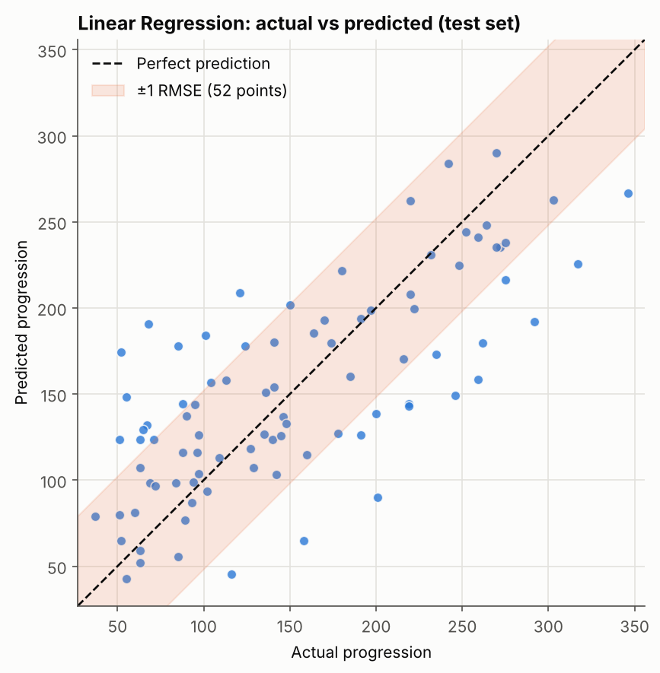
Figure 9.1: Actual and predicted progression for the test patients

9.4 Overfitting and underfitting
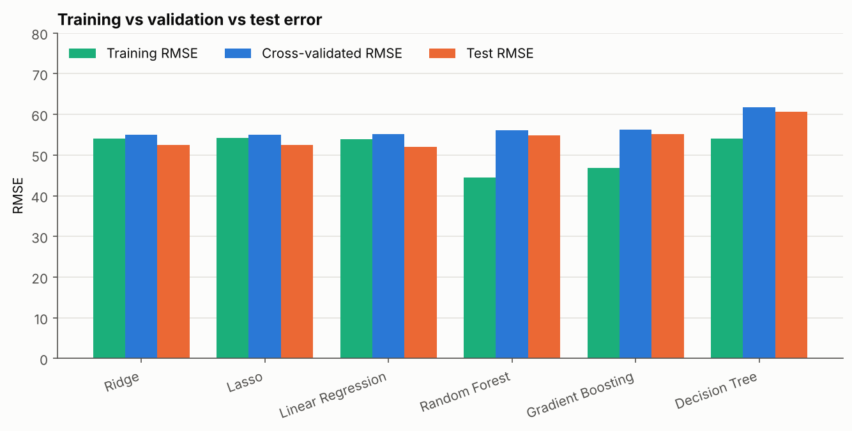
Figure 9.2: Training, cross-validated and test errors of all models
For the selected model the training RMSE is 53.9, the cross-validated RMSE is 55.2 and the test RMSE is 52.0. The three are close (the gap between training and validation error is 1.2), so the model is not overfitted. The tree-based models show the typical warning sign: Random Forest and Gradient Boosting fit the training patients much better than new ones (gaps of 11.7 and 9.4 RMSE points), yet they do not do better on validation data.
A linear model that explains 51 % of the variation on its own training data could be underfitting. However, the flexible models, which can fit much more, did not validate any better, so the remaining variation seems to be missing information, meaning factors that are not recorded in the ten measurements, rather than a model that is too simple.
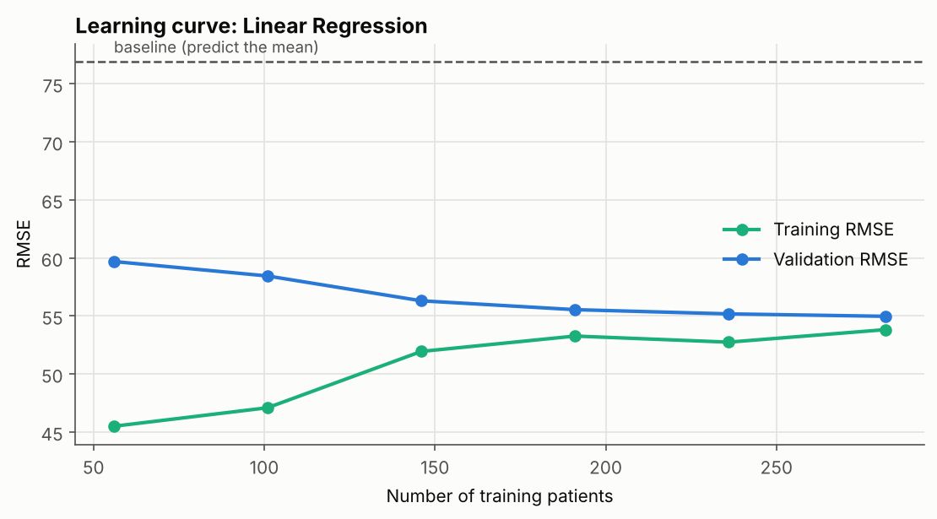
Figure 9.3: Learning curve of the final model
As the training set grows from 56 to 353 patients, the validation RMSE falls from 59.7 to 55.0 and then flattens, and the final gap between training and validation error is only 1.1. More patients of the same kind would add little. Better or additional measurements would help more than more rows.

9.5 Error analysis
The residual is the actual value minus the predicted value. A positive residual means that the model under-predicted, which is the more worrying direction for a risk tool, because the patient progressed faster than expected.
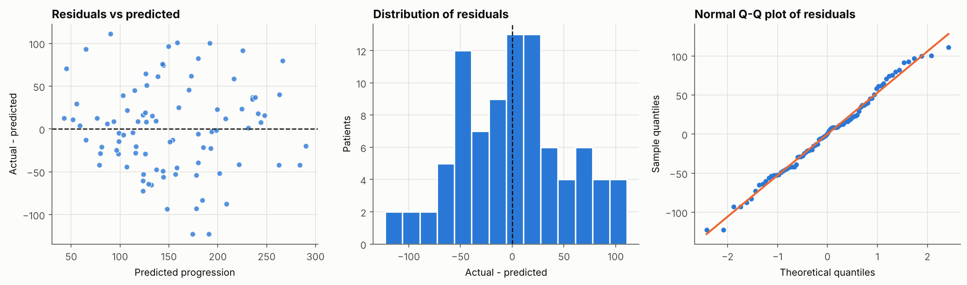
Figure 9.4: Residual diagnostics
The average residual is 0.10, so the model is unbiased overall. The residuals are consistent with a normal distribution (Shapiro-Wilk p = 0.61), and their size does not grow significantly with the predicted value (Spearman +0.16, p = 0.13). The typical spread is 52 points: 42 % of the test patients are predicted within 25 points and 65 % within 50 points.
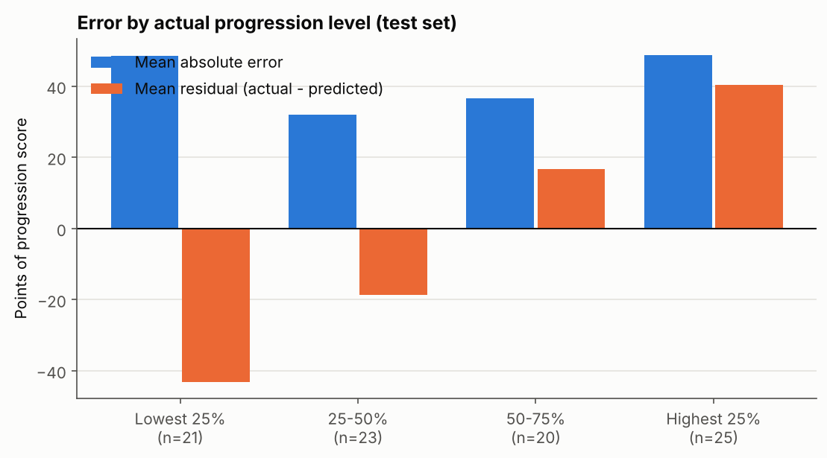
Figure 9.5: Prediction error by level of actual progression
Main error pattern: regression to the middle. Patients with the lowest actual progression are on average over-predicted (mean residual -43.2), and those with the highest progression are under-predicted (mean residual +40.5). Errors are largest at both extremes (MAE 48.6 and 48.8) and smaller in the middle (32.0 and 36.7). The model squeezes its predictions toward the average, which is normal behaviour when the inputs explain only part of the variation. As a consequence, the predicted score should be used to rank patients, and the fastest progressors will tend to have an actual score higher than predicted.
Errors by group. By BMI class the MAE is 31.5 (under 25), 50.6 (25 to 29.9) and 44.4 (30 and over); by sex code it is 42.8 and 40.1. The overweight group looks the hardest to predict, but each group has only 23 to 52 test patients, so these differences are suggestive and not conclusive.
Largest errors. The eight biggest misses are all above 90 points, and 62 % of them are under-predictions. They have no common profile (different ages, BMI and blood values), which indicates individual factors that none of the ten measurements capture.

Chapter 10: Results and Findings

10.1 Which measurements drive the prediction?
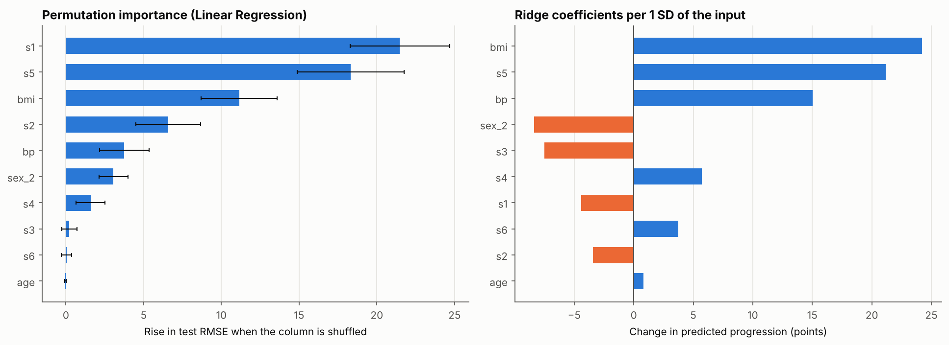
Figure 10.1: Permutation importance and Ridge coefficients
Table 10.1: Classical regression (OLS) coefficients on the training patients
Term | Coefficient | Standard error | p-value
intercept | 151.93 | 2.92 | <0.001
age | 0.41 | 3.18 | 0.899
sex_2 | -9.37 | 3.31 | 0.005
bmi | 25.45 | 3.55 | <0.001
bp | 15.63 | 3.59 | <0.001
s1 | -32.77 | 22.01 | 0.137
s2 | 18.16 | 17.95 | 0.312
s3 | 4.98 | 11.46 | 0.664
s4 | 8.85 | 8.75 | 0.312
s5 | 33.53 | 9.47 | <0.001
s6 | 3.24 | 3.52 | 0.357

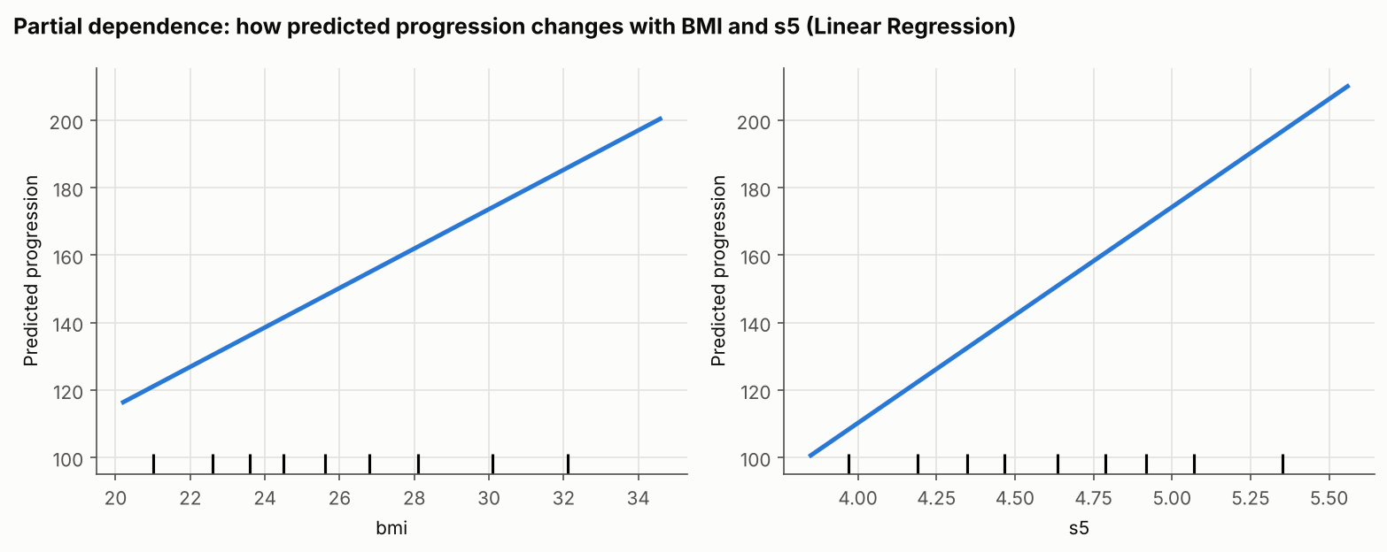
Figure 10.2: Partial dependence of predicted progression on BMI and s5
The left chart shows how much the test error rises when one column is randomly shuffled (permutation importance), and the right chart shows the Ridge coefficients per one standard deviation of each input. Table 10.1 gives the classical regression coefficients with significance tests. The partial-dependence plots show how the predicted progression changes with BMI and s5 when everything else is averaged out.
Robust drivers. The measurements bmi, s5 and bp stand out in every view. They top the Ridge coefficients (+24.2, +21.2 and +15.0 points per standard deviation), and each is significant in the regression (t = 7.2, 3.5 and 4.4). Predicted progression rises almost in a straight line with BMI and s5.
Sex. After adjusting for the other measurements, sex code 2 has a significantly lower predicted progression (-9.4 points, p = 0.005), although the raw averages hardly differed (Section 7.3). The direction cannot be interpreted because the meaning of the codes is not documented.
Cholesterol group. Permutation importance ranks s1 first (21.5) and s2 fourth, but in the regression s1 and s2 have opposite signs and are individually non-significant (p = 0.14 and 0.31). This is the multicollinearity described in Section 7.4: the model uses the contrast between the two correlated measurements, so their individual importance must not be over-interpreted. HDL (s3) is protective in simple comparisons (-0.37) but adds little once the other measurements are included (p = 0.66).
The top five factors in plain language are: (1) body mass index; (2) serum triglycerides (s5); (3) blood pressure; (4) the group of cholesterol measurements (s1 to s4, taken together, with HDL on the protective side); and (5) sex, after adjustment. The first three are the most dependable.
Correlation, importance and causation. Correlation shows that two things move together. Feature importance shows what the model relies on. Neither proves causation, and all results describe associations in this dataset only.

10.2 High-risk patient segments
Four easy-to-check risk indicators were defined from thresholds computed on the training set, so that nothing is learned from the test patients: BMI at or above 29.2, s5 at or above 5.00, blood pressure at or above 104 (the top quarter in each case) and HDL (s3) at or below 41 (the bottom quarter). A high progression means a score of 208 or more, which is the top 25 % of training patients.
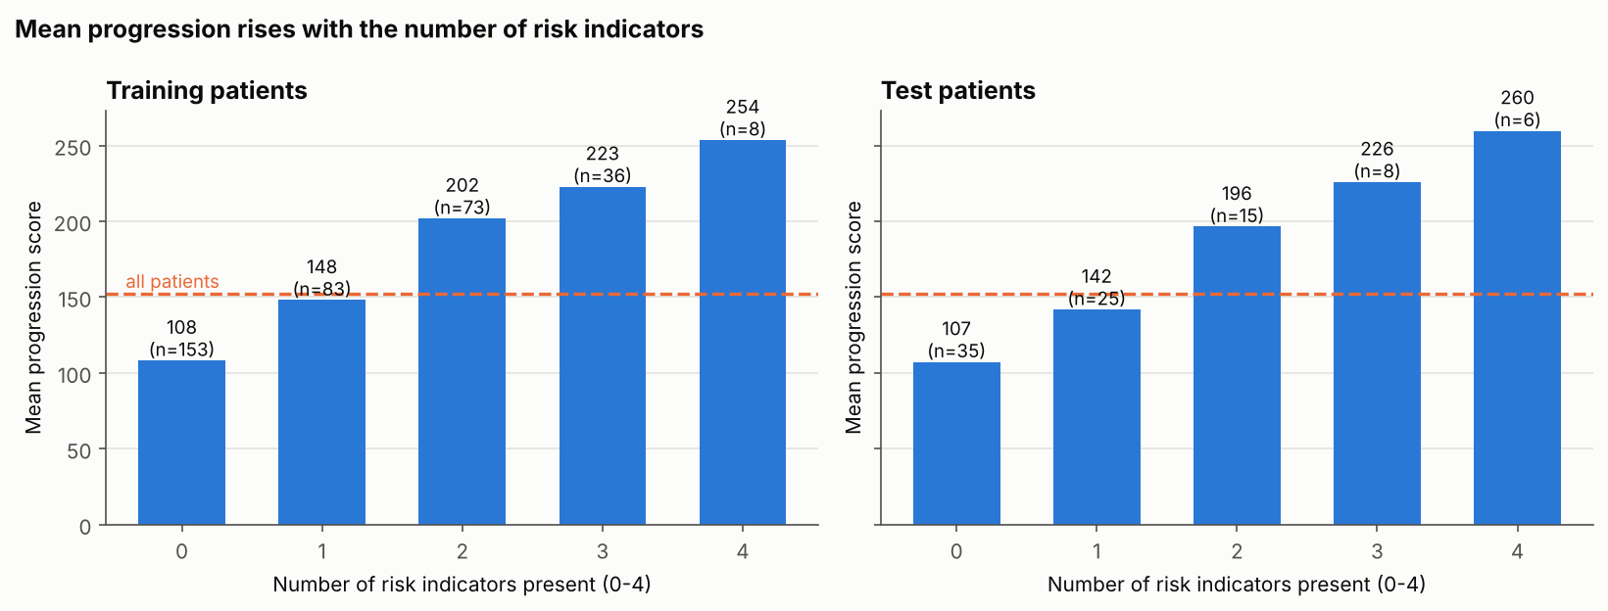
Figure 10.3: Progression by number of risk indicators
Table 10.2: Progression by number of risk indicators
Risk indicators present | 0 | 1 | 2 | 3 | 4
Training: patients | 153 | 83 | 73 | 36 | 8
Training: mean progression | 108 | 148 | 202 | 223 | 254
Training: share with high progression | 6 % | 17 % | 48 % | 64 % | 100 %
Test: patients | 35 | 25 | 15 | 8 | 6
Test: mean progression | 107 | 142 | 196 | 226 | 260

Mean progression climbs steadily from about 108 (no indicator) to about 254 (all four), and the same pattern appears in the unseen test patients (rank correlation +0.60, p = 5e-10). A patient with two indicators is far more likely to be in the high group (48 % in the training set) than a patient with none (6 %). Single variables show the same direction: 55 % of patients with BMI 30 and over are fast progressors, against 6 % of those under 25. For s5 the figures are 58 % in the top quarter and 0 % in the bottom quarter; for blood pressure 52 % and 9 %; and for HDL 40 % in the lowest quarter and 7 % in the highest. The groups with three or four indicators are small (the four-indicator group has only 8 training and 6 test patients), so their exact values are uncertain; the overall upward trend is the reliable finding.

10.3 Success criteria
Table 10.3: Success criteria set in Chapter 2 and the outcome
Criterion | Outcome
(a) Data quality fully documented | Met: Chapter 6 and Table 6.1.
(b) RMSE reduced by more than 25 % compared with the baseline | Met: 33 % lower on the test set (RMSE 52.0 against 77.7); cross-validated RMSE 55.2 against 76.9, which is 28 % lower.
(c) No sign of overfitting | Met: training RMSE 53.9, cross-validated 55.2, test 52.0.
(d) Errors analysed by patient group | Met: Section 9.5.
(e) At least three recommendations linked to findings | Met: six recommendations in Chapter 11.

10.4 Extension: flagging patients likely to progress quickly
Instead of the exact score, the model can be asked which patients will be fast progressors (the top 25 %). In the 89 test patients, 25 are fast progressors. Using the predicted score as the ranking, the ROC-AUC is 0.92 (1.0 is perfect and 0.5 is guessing). This is better than ranking by BMI alone (0.84) or by the number of risk indicators (0.87).
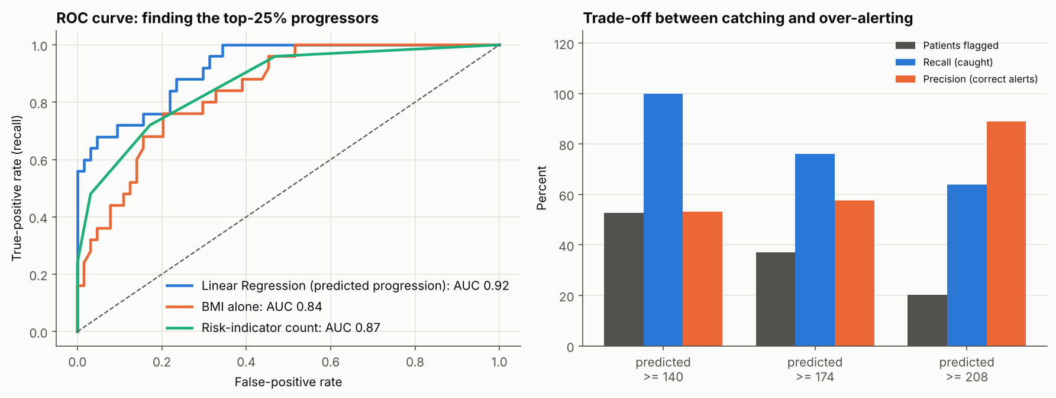
Figure 10.4: ROC curve and alert thresholds for fast progressors
Table 10.4: Alerts raised at three cut-offs of the predicted score
Alert if predicted score is at least | Patients flagged | Fast progressors caught (recall) | Alerts that were correct (precision) | Missed (false negatives)
140 | 53 % | 100 % | 53 % | 0
174 | 37 % | 76 % | 58 % | 6
208 | 20 % | 64 % | 89 % | 9

A false negative, which is a fast progressor who is not flagged, means that a patient who needed attention was missed. A false positive means an unnecessary alert. For a screening tool, missing a high-risk patient is usually worse than an extra check, so recall is the key metric and a lower cut-off is preferable: the lowest cut-off catches every fast progressor in this test set but flags about half of all patients. A higher cut-off is more precise but misses more patients. The right cut-off depends on how many patients a clinic can follow up. Only 25 fast progressors are in the test set, so these percentages could shift noticeably with different patients; they show the trade-off and are not guaranteed performance.

10.5 Summary of findings
Table 10.5: Main findings
ID | Finding | Evidence
F1 | The data are complete and unique | 0 missing cells and 0 duplicates in 442 patients
F2 | BMI, s5 and blood pressure are the most dependable indicators of faster progression | Correlations +0.58, +0.56, +0.46; significant in the regression
F3 | The lipid measurements overlap, so individual coefficients are unreliable | VIF up to 56.8
F4 | Engineered features do not improve prediction | RMSE change +0.35 (Ridge) against a standard error of about 1.9
F5 | Five models are statistically tied; the simple linear model is enough | Cross-validated RMSE 55.0 to 56.2
F6 | The model beats the baseline without overfitting | Test RMSE 52.0 against 77.7; R-squared 0.55
F7 | Predictions are compressed toward the average | Mean residual -43.2 (lowest quarter) and +40.5 (highest quarter)
F8 | The number of risk indicators separates patients well | Mean progression 108 to 254; same pattern in test patients
F9 | The model ranks fast progressors well | ROC-AUC 0.92

Chapter 11: Insights and Recommendations

11.1 Insights
The model is a ranking tool. The ten baseline measurements explain a little over half of the variation in progression. The model identifies likely fast progressors well (ROC-AUC 0.92), but the exact score can be about 42 points off, and the highest scores are systematically under-predicted. It is therefore best used to decide who should be reviewed first.
Simple beats complex here. Flexible models did not outperform a linear model, and engineered features did not help. The limit of the predictions is set by the information in the data and not by the algorithm. More patients of the same kind would add little; better measurements would help more.
Risk factors accumulate. Patients with high BMI, high triglyceride marker s5, high blood pressure and low HDL progress faster, and the effect grows with the number of risk indicators. Counting indicators is a simple rule that can be used even without software.

11.2 Recommendations
Each recommendation is tied to a finding. They are analytical proposals for a hypothetical clinic. Clinical staff must review them, and the expected effect is a direction and not a promised outcome.
Table 11.1: Recommendations
ID | Supporting finding | Proposed action | Priority | KPI to measure success | How to test it
R1 | Predicted score separates fast progressors well (AUC 0.92); four indicators give a steady rise in progression | Use the model score, or the four-indicator count when no software is available, as a triage ranking for follow-up appointments | High | Share of fast progressors reviewed early; recall of flagged patients | Run the ranking in parallel with normal scheduling for a few months and compare
R2 | 55 % of patients with BMI 30 and over are fast progressors against 6 % under 25 | Offer weight-management support first to the BMI 30 and over group | High | Change in BMI and in the progression score after 12 months | Pilot with a comparison group (needed because this is only an association)
R3 | s5 and blood pressure are robust drivers; progression rises with each extra indicator | Review lipid and blood-pressure results together and flag patients with two or more indicators | Medium | Share of patients with two or more indicators who have a documented plan | Audit records every quarter
R4 | Recall rises and precision falls as the alert cut-off is lowered (Section 10.4) | Choose the cut-off from capacity: a low cut-off for screening, a high cut-off for scarce interventions | Medium | Recall and precision on live data | Track false negatives and false positives every month
R5 | Predictions are about 42 points off on average and the extremes are compressed | Show predictions as a ranking or range and not as an exact score; treat the highest-risk patients as likely to be worse than predicted | Medium | Calibration of predicted against actual progression in new patients | Re-check residuals by risk band every six months
R6 | About half of the variation is unexplained and the learning curve is flat | Collect richer data (repeat measurements, lifestyle, medication, a defined score) before building a more complex model | Medium | Improvement in cross-validated RMSE after adding variables | Add variables in a small pilot and re-run the notebook

11.3 Expected benefits, risks and assumptions
The expected direction of impact is better targeting of follow-up and advice, with fewer fast progressors being missed. No financial or clinical benefit is quantified, because the data cannot support such a claim. The main risks and assumptions are that association is not causation, that the data come from one source and an unknown population, and that the model must be validated on local patients before any use.

Chapter 12: Limitations and Future Scope

12.1 Limitations
- Small, single-source data. The dataset has 442 patients and no information on selection, place or time. Results may not apply elsewhere.
- No external validation. Performance was measured on a held-out part of the same dataset; the 95 % interval for the test R-squared (0.39 to 0.67) shows how uncertain even that estimate is.
- Moderate predictive power. Only about half of the variation is explained, and individual predictions can be 100 points off.
- Multicollinearity. The cholesterol measurements overlap, so the individual coefficients for s1 to s4 are unreliable.
- Unclear variables. The target has no unit, the sex codes are undocumented and s4 differs slightly from s1 / s3.
- Association, not causation. All findings describe relationships in observational data.
- Small subgroups. Group-level error and segment results rest on few patients, especially the groups with three or four risk indicators.
- Not a clinical tool. No medical, ethical or fairness review was carried out.
- Tools. Streamlit, XGBoost and SHAP could not be installed in the environment in which the project was built, so scikit-learn's Gradient Boosting and permutation importance were used, and no interactive application was built.

12.2 Future scope
Future work could validate the model externally on a different patient group or a later period, collect richer data (repeated measurements, lifestyle, medication, treatment history and a precisely defined outcome), and try further methods such as interactions, splines, quantile regression for prediction intervals, XGBoost and SHAP explanations. Fairness and subgroup performance should be checked once the coding of sex is documented. The model could be turned into a simple tool, for example a dashboard that shows the risk indicators and an alert threshold, and monitored with the review plan in recommendation R5. Calibration and decision-curve analysis would help to choose alert thresholds together with clinicians.

Conclusion
The project answered its seven analytical questions with a complete and reproducible workflow. The data were complete and unique. Body mass index, serum triglycerides (s5) and blood pressure were the most reliable indicators of faster progression. Engineered features did not improve prediction, and the simplest tuned model, Linear Regression, was selected because five models were statistically tied. On 89 unseen patients it reached an RMSE of 52.0 points and an R-squared of 0.55, which is a 33 % reduction in error compared with predicting the average, without overfitting. The model is best used to rank patients: it identifies likely fast progressors well (ROC-AUC 0.92) but compresses extreme scores and leaves much of the variation unexplained. The most valuable next step is better data, not a more complex algorithm.
Through this capstone I practised each stage of the data-science process: defining a problem, checking and cleaning data, exploring it with statistics and charts, building and comparing models fairly, analysing errors honestly, and turning findings into recommendations that are linked to evidence.

References
- Breiman, L. (2001). Random forests. Machine Learning, 45(1), 5-32.
- Breiman, L., Friedman, J. H., Olshen, R. A. and Stone, C. J. (1984). Classification and Regression Trees. Wadsworth.
- Cohen, J. (1988). Statistical Power Analysis for the Behavioral Sciences (2nd ed.). Lawrence Erlbaum Associates.
- Efron, B. and Tibshirani, R. J. (1993). An Introduction to the Bootstrap. Chapman and Hall.
- Efron, B., Hastie, T., Johnstone, I. and Tibshirani, R. (2004). Least angle regression. Annals of Statistics, 32(2), 407-499.
- Friedman, J. H. (2001). Greedy function approximation: a gradient boosting machine. Annals of Statistics, 29(5), 1189-1232.
- Hanley, J. A. and McNeil, B. J. (1982). The meaning and use of the area under a receiver operating characteristic (ROC) curve. Radiology, 143(1), 29-36.
- Harris, C. R. et al. (2020). Array programming with NumPy. Nature, 585, 357-362.
- Hastie, T., Tibshirani, R. and Friedman, J. (2009). The Elements of Statistical Learning (2nd ed.). Springer.
- Hoerl, A. E. and Kennard, R. W. (1970). Ridge regression: biased estimation for nonorthogonal problems. Technometrics, 12(1), 55-67.
- Hunter, J. D. (2007). Matplotlib: a 2D graphics environment. Computing in Science and Engineering, 9(3), 90-95.
- Kruskal, W. H. and Wallis, W. A. (1952). Use of ranks in one-criterion variance analysis. Journal of the American Statistical Association, 47(260), 583-621.
- Mann, H. B. and Whitney, D. R. (1947). On a test of whether one of two random variables is stochastically larger than the other. Annals of Mathematical Statistics, 18(1), 50-60.
- McKinney, W. (2010). Data structures for statistical computing in Python. Proceedings of the 9th Python in Science Conference, 56-61.
- Pedregosa, F. et al. (2011). Scikit-learn: machine learning in Python. Journal of Machine Learning Research, 12, 2825-2830.
- Shapiro, S. S. and Wilk, M. B. (1965). An analysis of variance test for normality (complete samples). Biometrika, 52(3-4), 591-611.
- Tibshirani, R. (1996). Regression shrinkage and selection via the lasso. Journal of the Royal Statistical Society, Series B, 58(1), 267-288.
- Virtanen, P. et al. (2020). SciPy 1.0: fundamental algorithms for scientific computing in Python. Nature Methods, 17, 261-272.
- Waskom, M. L. (2021). seaborn: statistical data visualization. Journal of Open Source Software, 6(60), 3021.
- World Health Organization (2000). Obesity: Preventing and Managing the Global Epidemic. WHO Technical Report Series 894. Geneva: WHO.
- Diabetes dataset: scikit-learn documentation, sklearn.datasets.load_diabetes; source page named there: https://www4.stat.ncsu.edu/~boos/var.select/diabetes.html

Appendix

Appendix A: Objective-to-evidence map
Table A.1: Official objectives and where they are demonstrated
Official objective | Where it is demonstrated
1. Define the capstone problem | Chapters 1 and 2; notebook sections 1 to 3
2. Collect and prepare data | Chapters 4, 6 and 7; notebook sections 4 to 11; src/project_code.py; data/
3. Apply data-science techniques | Chapter 8; notebook sections 12 and 15
4. Build and evaluate the solution | Chapters 8 and 9; notebook sections 12 and 13; results/model_evaluation_results.csv; models/best_model.joblib
5. Analyse results, errors, limitations | Chapters 9 and 12; notebook sections 13.1, 14, 17 and 19
6. Generate insights and recommendations | Chapters 10 and 11; notebook sections 15 and 16; 17 charts in visualizations/generated_charts/
7. Document and present | This report; presentation/Final_Project_Presentation.pptx; README.md; reports/Viva_Preparation.docx

Appendix B: Key code
The preprocessing pipeline and the evaluation function are part of src/project_code.py. Every model in the project is built with the same pipeline, so that imputation and scaling are learned from the training rows only.
def make_preprocessor(numeric, categorical=(), scale=True):
"""ColumnTransformer: impute + scale numeric columns, impute + one-hot categoricals.

The dataset has no missing values, so the imputers do nothing on the
training data; they only make the pipeline safe for new, incomplete input.
It is always placed inside a Pipeline, so every step is fitted on training
data only (this prevents data leakage during cross-validation and testing).
"""
num_steps = [("impute", SimpleImputer(strategy="median"))]
if scale:
num_steps.append(("scale", StandardScaler()))
parts = [("num", Pipeline(num_steps), list(numeric))]
if categorical:
cat_steps = [("impute", SimpleImputer(strategy="most_frequent")),
("onehot", OneHotEncoder(handle_unknown="ignore", drop="first",
sparse_output=False))]
parts.append(("cat", Pipeline(cat_steps), list(categorical)))
return ColumnTransformer(parts)

def make_pipeline(model, numeric, categorical=(), scale=True):
"""Preprocessor + model in one scikit-learn Pipeline."""
return Pipeline([("prep", make_preprocessor(numeric, categorical, scale)),
("model", model)])

def regression_metrics(y_true, y_pred):
"""MAE, MSE, RMSE and R^2 in one dictionary."""
y_true, y_pred = np.asarray(y_true), np.asarray(y_pred)
if y_true.shape != y_pred.shape or y_true.size == 0:
raise ValueError("y_true and y_pred must be non-empty and the same length")
mse = mean_squared_error(y_true, y_pred)
return {"MAE": mean_absolute_error(y_true, y_pred), "MSE": mse,
"RMSE": float(np.sqrt(mse)), "R2": r2_score(y_true, y_pred)}

Appendix C: How to reproduce the results
Install Python 3.10 or newer, create a virtual environment, run pip install -r requirements.txt, open notebooks/Final_Data_Science_Capstone.ipynb in Jupyter Notebook and choose Restart and Run All. A complete run takes about two minutes and re-creates the data copies, all 17 charts, the saved model and the files in results/. The 32 automated tests are run with python -m pytest.

